Qualitative Study on Public Land Use at Heritage Center/ ETTP

Rayleana Schenkenfelder
Section #1: An Examination of the Potential Barriers along the “Consumer Path to Usage” for Heritage Center Greenway Trails, conducted with a focus group.
Section #2: Analysis of Strengths, Weaknesses, Opportunities, and Threats (SWOT) of Heritage Center Greenway Trails.
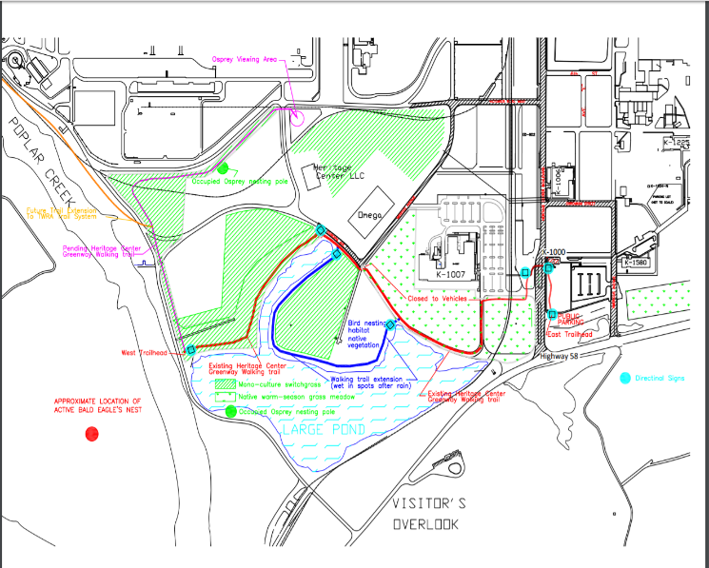
Section #1: Potential Barriers along the “Consumer Path to Usage” for Heritage Center Greenway Trails, conducted with a focus group. (Public Use)

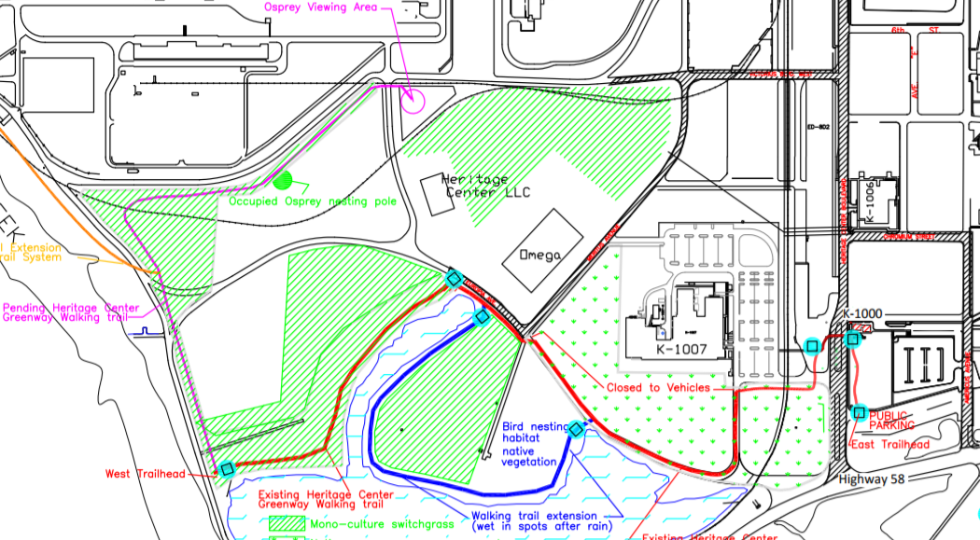
Sign #7

Sign #6

Sign #5

Sign #4

Sign #3

Sign #2

Sign #1

A focus group consisting of four Oak Ridge City residents left the East Trailhead on a Wednesday at 430pm. None of the individuals had previously been on the trail and did not know it existed. The individuals walked the trail like they might otherwise do during their daily activities. Their perceptions, impressions, and feedback were recorded along the way.
Pond Trail beginning at the East Trailhead
- People are often confused about the appropriate entrance to access the East Trailhead: Americus or Heritage Blvd. Both entrances have “HERITAGE CENTER” signs with no obvious main entrance marked.

  - All participants arrived in two vehicles. Both drivers were confused about finding the “main entrance on Heritage Blvd, turn right into the first visitors parking lot.”
  - Participant 1 remarks: “We didn’t know, we turned at the first road with the big Heritage sign”.

- Once on the trail, the #2 “Heritage Trail” sign is not obvious enough to direct people to cross the street. Rather, people continue onto the sidewalk toward building 1006. After a few minutes, I asked them to turn around to avoid venturing into badged area.

  - Participant 1 remarks: “I didn’t even see that sign, I was just following the sidewalk.”
  - Participant 3 remarks: “I didn’t either.”

- The #3 “Heritage Trail” sign directs people with an arrow to walk across the grass and into the roadway. No trail exists here, and people walk in the roadway. Often, people must move out of the road for passing vehicles.

  - Participant 4 remarks: “Why does the arrow point this way, away from the sidewalk?”
  - Participant 2 remarks: “There isn’t even a trail here.”

- If, instead, people disregard the #3 “Heritage Trail” sign and continue toward building 1007 on the sidewalk, they must walk directly thru the building 1007 main parking lot, through some passing vehicles, and the sidewalk ends at the building. No signage is in place to direct people from building 1007 to the beginning of the gated old road trail area. I directed everyone to the gated old paved road area.

  - Participant 1, ending at building 1007: “Where do I go from here?”
  - Participant 2: “Oh, this gate is cool. At least, you feel safe like no car will enter here.”

- Once everyone is on the old paved road trail, “NO TREPASSING” signs are located approximately 1/8 mile into the gated old road trail on the left.

  - Participant 1 remarks: “It feel like this is a badged area, and we should not be here.”
  - Participant 2 remarks: “It does not feel safe to be here.”

- A rather large industrial outfall is in place along the paved road trail on the right about 1/4 mile into the old road trail area, cordoned off with “WARNING: STOP” signs in the greenway.

  - Participant 2 remarks: “This is odd, should we be in this area?”
  - Participant 4 remarks: “It feels like we’re on DOE property, and we are being watched.”
  - Participant 3 remarks: “Are you sure this is an actual greenway?”

- The pond is lined with “NO FISHING OR RECREATIONAL USE” and “Industrial Storm Water Runoff” signs throughout all areas of the Pond Trail.

  - Participant 1 remarks: “I feel like if I were to trip and fall in there, I might get poisoned or something.”

- Group walks along the unpaved loop trail.

  - Participant 4: “This is cool. It looks different than other greenways I’ve been on.”
  - Participant 2: “I’m a runner, and runners are always looking for new terrain to run on.”
  - Participant 3: “This is why people come from Knoxville to Oak Ridge. It’s for the greenways here.”
  - Participant 4: “It is so busy and noisy next to the road here.”

- The 2nd gate along the paved old road has a “PRIVATE DRIVE” sign.

- No trail exists between #6 and #7 “Heritage Trail” signs. People must walk along the mowed shoulder of the roadway, which is present along both sides of the roadway throughout ETTP. No trail exists. Sometimes, people walk in the roadway, and they must move to the side for passing vehicles.

  - Participant 1 remarks, as she removes her child from the roadway: “This can’t be a greenway.”
  - Participant 3 remarks: “It does not feel safe to be in the road.”

- The 6th “Heritage Trail” sign directs people with a dual arrow to continue either toward the West Trailhead or across the roadway and toward Omega building. No trail exists in the direction of Omega building, and people walk in the roadway.

  - Participant 2 remarks: “How funny, it points nowhere. I’m pretty sure they don’t want you walking over that chain link fence.”
  - Participant 4 remarks: “This can’t be right.”

- Although Google Maps and other online trail maps show a continuation of trail from the West Trailhead toward the Osprey nesting pole and Osprey viewing areas, no trail exists; only a mowed shoulder of the roadway is present, which exists on both sides of the roadway around ETTP. People walk in the roadway.

  - Participant 4: “Can you mow the grass and call it a greenway?”
  - Participant 2 remarks: “Apparently here, you can.”

- After the bend turns to the right toward the Osprey nesting pole, a sign is present that states “US Dept of Energy Area”.

  - Participant 2 remarks: “Now, I definitely don’t think we are supposed to be here.”

- People refuse to continue walking in roadway/greenway any further, and we return to the East Trailhead.

  - All participants were female and noted that they would be hesitant about safety in this location because of the distance from town in either direction.

- ETTP Trails Focus Group Complete.

Other potential barriers to customer pathway purchase noted below.
Perimeter Road beginning from Highway 95 to reach the West Trailhead
- Immediately after turning onto Perimeter Road, people are met with a sign reading “US Government Property, Not Open to Public Beyond This Point, Official Use Only: Trespassers May Be Prosecuted”.

Perimeter Road beginning from Blair Road to reach the West Trailhead
- Immediately after turning onto Perimeter Road, people are met with a sign reading “US Government Property, Not Open to Public Beyond This Point, Official Use Only: Trespassers May Be Prosecuted”.

Part #2: SWOT Analysis of Heritage Center Greenway Trails. (Public Use)
(Public Use)
- Air smells very clean and fresh.
- During non-work hours, little noise pollution.
- During evening hours, little light pollution.
- Very quiet, hardly see anyone else on trails.
- A lot of birds & wildlife present.
- Distance from town: peaceful when highway is not busy.
- Beauty of biodiverse & native habitat.

- Protected wildlife areas: public encroaching on habitat.
- Lack of funding preventing greenway progress.
- Several greenways areas are mowed shoulders on roadways: physical hazard & liability concern.
- Industrial outfalls: physical hazard & liability concern.

- Distance from town: personal safety concern.
- Feels like a “badged area”.
- Signs directing people to leave site: “No Trespassing”.
- Lack of trail route signage & confusing directional signs.
- Ominous signage is unwelcoming & frightening.
- Most sections of greenway do not loop.
- Short distance of greenway trails.
- Possible blueways piqued interest!
- Stargazing or astronomy groups: low light pollution.
- Rugged, unpaved terrain attractive to runners.
- Gated, paved road attractive for joggers.

